We thank the Editor and the Reviewers for their constructive comments and suggestions. We have addressed the raised questions and comments below. Modifications are indicated in the “multiple-imputation-manuscript-tracked.docx” and “supplementary-tables-tracked.docx” files using track changes. In our answers below, we refer to the corresponding page and line numbers in this tracked file's “All Markup – showing all revisions inline” display. The “multiple-imputation-manuscript-clean.docx” and “supplementary-tables-clean.docx” files are the clean versions of the revised manuscript and supplementary tables, respectively.

Reviewer #1:

General
- Some imputation methods, mostly the ones not based on sampling with variability, artificially and incorrectly reduce the variability in the data and might introduce bias (for example, if all missing ages are imputed by the same age value, mean/median or other). This presumably holds for the PMM algorithm, too (l. 222ff.). A discussion of this appears appropriate.
We have added a brief discussion acknowledging the limitation. [Page 12, lines 244-245]
- l. 231ff.: It is not obvious from the description, at least not to me, why PMM is "a reliable method against model misspecification" and I would like to see further elaboration.
We have clarified this now. [Page 12, lines 239-240]
- I envisage applications of imputation methods mostly for large population PK/PD models using clinical phase 2 and phase 3 data. Phase 1 data rarely have missing values due to the typically well-controlled environment. The large PK/PD models are frequently built under time pressure. In order for the approach to catch on in practice, readers should be provided with a clear overall algorithm, including identification of imputation models and everything else. Can the authors provide some sort of algorithm for creating an appropriate imputation approach, going as far as discussing semi- or fully automated algorithms.
It seems key for a wider use of these methods that the authors support pharmacometricians by a clear flow and support with (semi-) automated procedures. Please consider an algorithm definition for the entire approach, similar in layout as the current Table 2, substantially expanding the current Figure 1 into a figure that guides the modeler through all steps in detail.
Much of what is presented and discussed in this manuscript is published elsewhere (including the documentation of the mice R package, https://doi.org/10.18637/jss.v045.i03). This is acknowledged by authors ("Our study is not the first to present an MI workflow in pharmacometrics, but it is the most comprehensive", l. 522/23). Still, I see value in adaptation of the existing methods to pharmacometrics applications, in particular if the authors could move closer towards a very clear algorithm (as suggested in the previous paragraph).
Thank you for this very important comment. We have expanded Figure 1 based on your suggestion. Specifically, we now specify a 5-step workflow instead of 4, and we have added detailed guidance for each step in the figure. We also added the detailed algorithm to the manuscript. [Page 13, lines 263-287]
Furthermore, we adapted the manuscript to make sure that it is entirely pharmacometrics-focused. [Page 8, lines 157–165; Page 10, lines 198-199; Page 14, lines 298-299; Page 15, line 316; Page 16, line 351; Page 17, lines 372-373; Page 17, line 380]
- Simulation scenarios with half or more of the data missing appear very unrealistic to me but might still be interesting for completeness of the assessment. It would be useful if the missing records with 50% of the data missing would include the same missing records as the data sets with 6.25%, 12.5%, and 25% missing data, but I appreciate that this might be more difficult to implement. It could be done if the 75% missing data would be created first and some of the data be put back in to achieve other percentages of missingness.
The manuscript should at least be clear on whether or not these missing records are subsets of one another (l. 450ff.).
It is indeed known that not all observations provide the same amount of information on the parameters of interest. Comparability of e.g. the 50% and 25% missingness scenarios may thus be undermined when the occurrence of missingness differs in both scenarios. It is our understanding that this is what the Referee hints at when proposing to subset the percentages of missingness. However, the effect is expected to be negligible in our analysis as we repeated each scenario 30 times. Consequently, the occurrence of missingness varies in each simulation, which is expected to average out over the scenarios. Therefore, as suggested by the Referee, we now clarified that “Missing records are not subsets of one another. The high number of iterations is expected to minimize the impact of different occurrences of missingness across missingness scenarios, thereby guaranteeing comparability.” [Page 22, lines 497–499]
- Computer runtime is an issue when it comes to full pop PK models with thousands of records doing covariate analysis and, on top, multiple imputation at each step. This aspect should be added to the discussion, and it might be interesting to see the runtimes for the warfarin model using a very small data set, best on a small computer such as a laptop (the authors appear to have used a supercomputer).
Thank you for this comment. We added the runtime aspect to the Discussion section and reported the runtime for our Warfarin case study, as well as the infrastructure we used to run it. [Page 32, lines 721–727]
- One of the advantages and simultaneously disadvantages with R is the availability of a huge number of packages written by thousands of authors, largely unknown. I suggest that the authors of this manuscript help the readers by providing comments on the quality of the packages they reference in Table S1. How far can these be trusted for correctness? The authors comment that ignoring the mechanisms of missingness can cause severe biases. Wrong results based on errors in R packages have the same potential of causing harm to patients.
We added the status and main developer of these packages in the footnotes of Tables S1 and S2 in the “supplementary-tables-tracked.docx” file. Additionally, we included some metrics suggested by the packagemetrics package (https://ropensci.org/blog/2017/06/27/packagemetrics/) in the Supplementary Code and Dataset.
- It would substantially strengthen the point that (multiple) imputation is important and can be done if the authors could reference pharmacometrics works where this has been done, best in submission activities.
We emphasized in the Discussion that the application of multiple imputation in pharmacometrics has been growing recently, and we cited seven pharmacometrics works. [Page 27, lines 603-605]

Details
- The cover letter states that "The authors declared no competing interests in this work" while the author form states that "There is a conflict of interest. Erwin Dreesen received consultancy fees from ...".
The statements look contradictory.
We apologize for this confusion. The conflicts of interest mentioned in the author form are not related to this work. We initially included these in the author form, for full transparency, but to avoid any confusion, we have now removed these and stated that we have no conflict of interest related to this work.

Abstract:
- it is stated that multiple imputation is preferable over single imputation with not even a hint of why that may be.
We apologize this may not be sufficiently clear. We now clarified that “Multiple imputation, in contrast, generates multiple plausible values from a predictive distribution, addressing this uncertainty and thus is a preferable approach over single imputation to handle covariate missingness.” [Page 2, lines 36-37]

Introduction:
- It is a bit surprising that industry guidances such as the ICH guidance documents are not referenced (for example ICH E9, section 5.3 on missing values and outliers). This guidance complicates the matter by suggesting performing the analyses on different data sets and I wonder how the approaches suggested here fit into this context. Such a discussion is probably best placed in the discussion section, not the introduction. The authors could even go as far as suggesting an update of the guidance document to encourage using imputation techniques.
We cited the ICH Topic E9 Statistical Principles for Clinical Trials (CPMP/ICH/363/96) document in the Introduction section. [Page 3, line 53]
The Referee is correct. Section 5.2 in the ICH E9 guidance does mention different analysis sets, including the full analysis set and the per protocol set. While the full analysis set contains all patients in the clinical trial, the per-protocol set only includes patients who are more compliant with the protocol, including patients with no missing data. Such complete case analysis is indeed suboptimal, and imputation techniques such as multiple imputation should be used instead. Although subsection 5.2.1 of the guidance touches upon imputation techniques, the last observation carried forward method is highly prone to bias. We have mentioned this aspect in our Discussion section: “The ICH E9 guidance on statistical principles for clinical trials encourages the use of imputation techniques to minimize the missing data problem, thereby mitigating the need to use different analysis sets. However, this guidance recommends the LOCF technique, which is highly prone to bias. In pharmacometrics handling covariate missingness has also not yet been optimal, as pharmacometricians commonly employ SI, a technique that replaces the missing covariate with a single value and treats it as if it were true”. [Page 27, lines 595-602]

Simple methods for handling missing data:
- l. 93ff: "in biomedical/pharmaceutical research where it is not uncommon for more than half of the data to be incomplete": I have never seen a clinical data set with more then half the data incomplete and doubt that this is "not uncommon", this appears to be a bit of an exaggeration.
We agreed with the Referee and removed our sentence. [Page 5, lines 94-96]
- l. 107ff: imputing by means or medians reduces variability estimates and acts as another kind of shrinkage in pharmacometrics applications, which could be mentioned here.
We have now rephrased it to “…mean or median imputation reduces variability estimates because it treats imputed values as if they were truly observed, ignoring the uncertainty associated with the missing observations.” [Page 5-6, lines 106-109]

Multiple imputation of missing covariate data:
- l. 141ff: The references provided are useful. The classic works of Dempster, Laird, and Rubin (1977) and the EM algorithm should be mentioned here, too, I think.
Reference: https://doi.org/10.1111/j.2517-6161.1977.tb01600.x
We added the reference and stated that EM is another valid approach for missing at random data. [Page 8, lines 146-148]
- l. 170ff: splitting the data into two sets requires a reasonably large data set to start with, which is usually only available with clinical Phase 3 data.
It should be helpful if you could reference an R package that you deem to be useful while the reference to Heymans and Eekhout with applications in SPSS (which is not a pharmacometrics software) appears not very useful.
We have referred to two R packages finalfit and naniar in our manuscript. [Page 9, lines 180-181]
- Table 2: I don't see why a table is created to show an algorithm. A numbered bullet-list appears more appropriate and can be placed exactly into the text where it is discussed (while a table is a floating object).
- Various places in Table 2: "each of the k missing covariates" should be "each of the k covariates with missing values" (it is not the covariates that are missing but the values).
- It seems that an "else" statement is missing for step 3 ("If a linear regression model is fit"), it seems undefined what to do if the model is not linear (and maybe none of the imputation models).
- Actually I don't see why the restriction to linear models is there at all, it seems that other models, for example any model fit using least-squares regression, could be employed.
- There should be a short discussion on how much results might differ depending on the sequence of covariates imputed, appreciating that generalization is difficult and, for large numbers of sampling steps, it averages out.
We implemented your suggestions and replaced Table 2 with a numbered bullet list in the manuscript text. [Pages 12-13, lines 262-287].
Furthermore, we added the following to the Discussion: “We used the FCS algorithm for doing MI, which has the main advantage of not having to pre-specify a sequence in which covariates are imputed, thus ruling out that there might be any impact of the chosen sequence. To what extent the results of alternative approaches are impacted by the choice of sequence of imputation would require an extensive, dedicated simulation study, which is outside of the scope of our work.”. [Page 28, lines 636-640].
- l. 267ff: the suggestion that "if the pharmacometrics model includes an interaction term, this term must also be in the imputation model" is justified but very hard to implement in practice: such interaction terms are commonly not defined from the very beginning in PK/PD modeling but introduced during model development. This in turn would ask for changing the imputation model during model development by adding an interaction term.
The Referee is correct. We have rephrased it to: “Theoretically, this means that if the pharmacometrics model includes an interaction term, this term must also be in the imputation model to avoid having a biased interaction estimate. However, such an interaction term is commonly only introduced during model development, undermining practical implementation.” [Page 14, lines 303-307]
- l. 281ff: there are different formulas for BMI and eGFR, some of which include other covariates such as race.
We added two references number 39 and 40 for our two equations. [Page 15, line 320]
- l. 307ff: FCS is not spelled out on first occurrence but on third occurrence later.
We have spelled out FCS on its first occurrence. [Page 12, lines 256-257]
- l. 363ff: clearance and volumes are commonly assumed to be lognormally distributed, not normally. Is this what is meant by "approximately" normally distributed?
I note that optimization (model fitting) generally happens in the multivariate normal space after transformations into this space.
Indeed, individual PK parameters are commonly assumed to be lognormally distributed. Therefore, to avoid confusion, we have now rephrased it to “Examples of such parameters in pharmacometrics are typical PK parameters such as clearance or volume of distribution”. [Page 18, lines 405-406]
- l. 401: "to be converged" should be "to have converged".
We have corrected the phrase. [Page 20, line 444]
- l. 406ff: "high-quality imputations should have a similar distribution to that of the observed data" would be correct in MCAR situations but appears incorrect in the settings discussed here (non-MCAR).
The Referee is correct. We have rephrased the sentence accordingly: “The rationale behind this approach is that high-quality imputations should be plausible.” [Page 20, lines 450–452]
- Table 3: it seems discomforting to see that a larger fraction of models did not converge. The models not converging are most likely not completely random either but dependent on, for example, extreme covariate values. This appears to be a major issue with respect to credibility of the methods and the analysis. Please provide a very specific description of how convergence (or lack thereof) was diagnosed here (best as footnote to the table).
We removed Table 3 since the convergence rate for both multiple imputation and single imputation is 100% now. This improvement in convergence rate is due to the enhanced model stability after removing IIV from Ka. [Page 22, lines 488-489]
- l. 465 ff: the description of the implementation is insufficient: in particular, which fitting algorithm was used (FOCE, FOCEI, SAEM, or other)? I can easily imagine differences in convergence rates between algorithms.
We have added the information regarding the fitting algorithm to our manuscript. [Page 23, lines 516-517]
- l. 560: the definition of "multivariable" missing covariates is not clear to me, please provide a brief description here or rephrase.
We corrected “multivariable” to “multivariate” on Page 29, line 653. The definition of multivariate missingness is provided on Pages 9-10, lines 189-190 of our manuscript.
- l. 586ff: general superiority cannot be established based on few case studies, different data sets may well produce different results.
The Referee is correct. Yet, the purpose of our work was not to demonstrate the general superiority of MI as this is already established in general biostatistics literature.¹ Due to some changes in our case study that we have mentioned in question 22, we have now replaced that sentence with “The superiority of MI over SI in our case study was demonstrated to be more profound in correctly reflecting the uncertainty of all parameter estimates, including covariate effect estimates, across all missingness scenarios”. [Page 30, lines 687-689]
1. Molenberghs G, Verbeke G. Models for Discrete Longitudinal Data. Springer New York: New York; 2006.
- The references require another proofreading:
Ref 9 has author names all in uppercase.
Ref 10 has "Certara USA I." as author.
Refs 13, 15, 18, 46, 53 are not helpful in finding the reference, please provide a URL.
Ref 20 has no publisher nor journal.
Ref 24 should have the journal name spelled out.
Ref 36, a book, has the publisher location, other books do not.,
We corrected the format for these references. [Page 34, lines 763-764; Page 35, lines 765-766; Page 35, lines 777-781; Page 35, lines 784-787; Page 36, lines 798-799; Pages 39, lines 874-877; Page 40, lines 895-896; Page 36, lines 808-809; Page 37, lines 818-820; Page 38, lines 851-852]
- Figure 2: "(a)" is probably better one of the standard footnote symbols (asterisk, hashmark, etc.).
We replaced (a), and (b) in our Figure 2 with (#) and (‡), respectively.
- Figure 3 seems useless for concluding anything from it, and the width of the kernel smoother appears too small.
Thank you for this comment. We finetuned the figure to enhance the visibility of the kernel smoother and put the figure into the supplementary file. [Page 23, lines 518-519]

Reviewer #2:
- P13, L270-277: It is stated, that the outcome variable must be included in the imputation model, e.g., drug concentrations at all time points. While for longitudinal covariates, such as SCr, this might be best, I'm not sure whether taking multiple concentration measurements as predictors for the imputation in the presented case example is beneficial, as the imputed covariate weight does not change substantially in such a short time (in the provided R code, it looks like authors then simply average over imputed weights at different timepoints with quite large variability ranging from 62 to 104 kg in subject 24 in the first imputation run). Can the authors please elaborate their reasoning for this approach instead of, e.g., initially estimating PK parameters without covariate effects and using estimated individual PK parameters (Cl, V etc.) in the imputation? (Authors briefly mention this approach in the discussion, however don't elaborate in more detail)
Follow-up to comment 1: Authors use ID, TIME, and AMT for the imputation:
- ID is a randomly assigned number, is it reasonable to include this variable in the imputation?
- TIME (similar to concentration at different timepoints) seems to complicate the imputation as at different timepoints, different weights are predicted for the same subject and authors then simply average over imputed weights per subject
- While the applied dose seems to be useful for imputation, at "non-dosing timepoints", AMT is zero for most rows. Wouldn't it make sense to only include AMT at dosing-events, because giving a dose vs not giving a dose does not influence weight but given dose-amount might be important?
The Referee is correct. It indeed makes more sense to use the individual PK parameters as predictors in our imputation model since our covariate body weight is a baseline covariate. We thus performed an additional analysis using the estimated individual PK parameters as predictors in the imputation model (model 2) instead of time and drug concentration (model 1). [Page 23, lines 505-509]
However, we noticed that the performance of multiple imputation is worse for model 2 compared to model 1. This may be because the individual parameter estimate lacks information due to eta-shrinkage, which we have added to our Discussion section. [Page 31, lines 704-707].
For the second part of the comment, we agree with the Referee regarding removing ID from the imputation model. We kept TIME in the imputation model to make sure that the imputation model is compatible with the analysis model since TIME is also a variable in the analysis model. We then averaged WT per patient since WT is a time-invariant covariate in our case. For AMT, we kept it in model 1 and removed it in model 2, as AMT is highly correlated with WT in model 2. The correlation matrix for both models in the scenario with 12.5% body weight missing is presented in Figures A and B below.
In addressing this comment, we noticed that our popPK model was unstable thus we removed the IIV from Ka to improve the model stability. This in turn led to the convergence rates for both our imputation methods to be 100%. [Page 22, lines 488-489; Page 24, lines 542-547]
Other changes we made to address this comment are in [Page 24, lines 536-537; Pages 25-26, lines 567-582; Page 30, lines 674-677; Pages 30-31, lines 687-703].
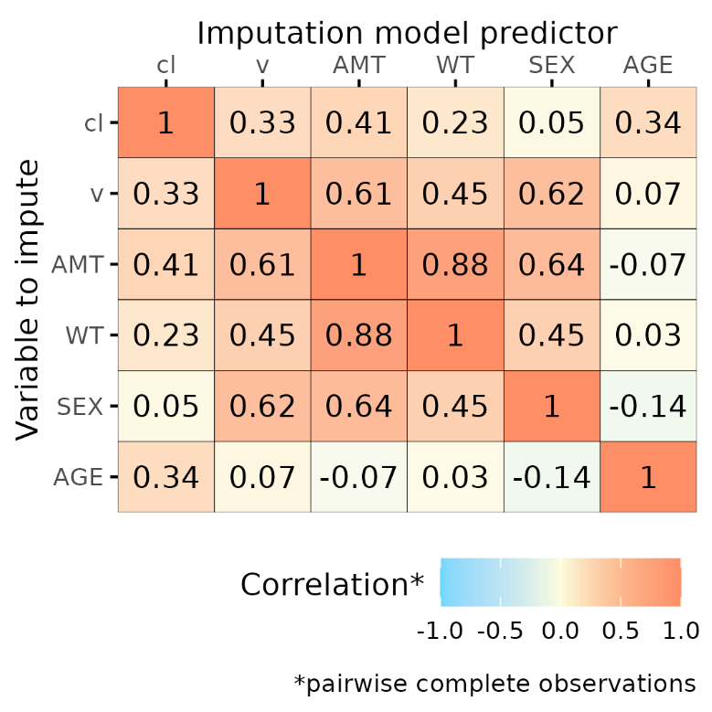
Figure A. Correlation matrix for the model with estimated individual PK parameters as predictors
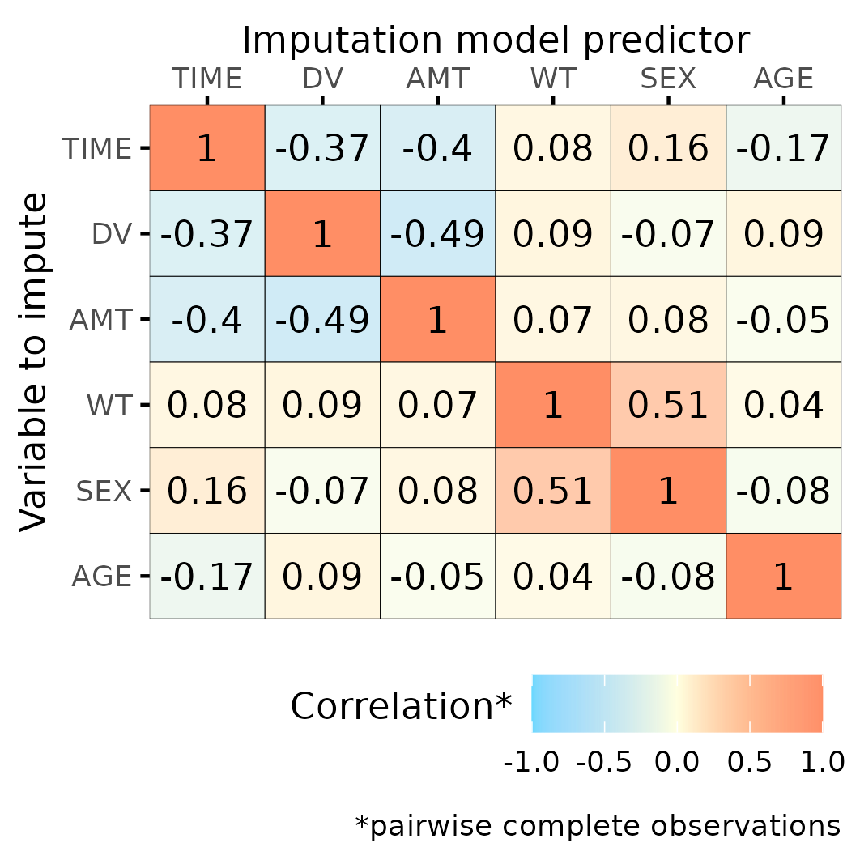
Figure B. Correlation matrix for the model with time and drug concentrations as predictors
- P13, L278ff: Considerations on how to handle derived covariates is very interesting. For a tutorial, it would be helpful to have a simple (dummy-) code snippet to illustrate the three options.
We provided code snippets to demonstrate the three options in our Supplementary Code and Dataset. [Page 16, lines 349-350].
- P17, L366: Could you please elaborate, what transformations are required before applying Rubin's rule to random effects estimates?
We have now added “…a transformation to a normal distribution, for instance using log transformation , is required before Rubin’s rule can be applied”. [Page 19, lines 408-409]
- It would be interesting to see point estimates and standard error biases for the other estimated parameters, i.e., ka, Cl, and V (maybe in the supplements), and not only for weight effect on Cl and V.
We added these figures to our supplementary materials (Figures S2-S3 & S6-S7). We also reported the results for these structural PK parameters. [Page 24, line 540; Page 25, lines 554-559; Page 26, lines 583-591]
- A more in-depth discussion for figures 4 and 5 would be helpful, i.e., what results are expected/desired would be helpful, e.g., obviously small relative biases for estimates, but also more consistent and potentially larger relative biases for standard errors due to uncertainty coming from missing values.
We reported additional overall results [Page 25, lines 552-559] and provided more substantial discussion regarding these results [Page 30, lines 666-673].
- The provided R code in the supplemental material is highly appreciated. However, more comments/ more detailed description of what is done in the provided R code would be helpful for pharmacometricians that want to apply MI in their analysis, especially as this is a tutorial.
We added more comments and detailed descriptions to our R code in the Supplementary Code and Dataset.
- It is perfectly reasonable to apply the median of the weights in the complete dataset to log-transform weight in the PK model in order to compare the resulting estimates. However, a naïve user might be tempted to apply the median of the imputed weights for the log-transformation which would result in non-reasonable pooling of the estimates with Rubin's rules. Thus, it would be helpful to highlight in this tutorial, that for a real-life application where no complete dataset is available, a fixed value (e.g., 70 kg or median of observed bodyweights) should be utilized to log-transform weights in all imputed datasets.
Thank you for this comment. We clarified that we used the median observed body weight of each incomplete dataset for imputation [Page 23, lines 502-503], and we cantered the body weight effect around the median observed BW of the complete dataset, which is 71.7kg. [Page 22, lines 490-492].

Editorial Office Comments:
- The author contributions section can be removed, as it is not required for this manuscript type.
We removed the author contributions section.

